**BLOOD LINK: A MOBILE-BASED HYBRID BLOOD BANK FOR RED CROSS MUNTINLUPA CHAPTER**

A Capstone Project Presented to the Faculty of the

College of Information Technology and Computer Studies

Pamantasan ng Lungsod ng Muntinlupa

In Partial Fulfilment of the Requirements for the Degree

Bachelor of Science in Information Technology

**JANREY CYRIL C. FADERANGA**

**KYRAH A. PANGILINAN**

**MARY GRACE S. SANTARIN**

**2024**

**TABLE OF CONTENT**

**PRELIMINARIES Page(s)**

Title Page

Table of Content

List of Figures

List of Tables

**CHAPTER**

1. **INTRODUCTION**

Project Context

Purpose and Description

Objective of the Study

Scope and Limitation

1. **REVIEW OF THE RELATED LITERATURE AND STUDIES**

Technical Background

Related Literature

Related Studies

Definition of Terms

1. **METHODOLOGY**

Requirement Analysis

Requirement Documentation

System Architecture

Design of Software, Systems, Product and/or Processes

Development and Testing

Implementation Plan

**REFERENCE**

**LIST OF FIGURES**

**No. Title Page(s)**

1 Sample Screen of Sample page

2 Sample Screen of Sample page

3 Sample Screen of Sample page

4 Functional Decomposition Diagram

5 Function Decomposition Diagram of the proposed system

6 System Architecture of the proposed Application

7 Conceptual Model Of the study

8 Rapid Application Development (RAD) Development

**LIST OF TABLES**

**No. Title Page(s)**

1 Alpha Testing

2 Beta Testing

3 System Evaluation Characteristics

4 Likert Scale

5 Implementation Table

**CHAPTER 1**

**INTRODUCTION**

**PROJECT CONTEXT**

The Mobile-Based Hybrid Blood Bank for Red Cross Muntinlupa Chapter is a strategic effort to modernize the blood bank system by integrating mobile technology. It aims to transform interactions between donors and recipients with the Red Cross Muntinlupa Chapter, making blood donation more accessible, efficient, and engaging through a hybrid system that combines a mobile app with traditional blood bank operations.

The primary problem addressed by this project is the inefficiency and limited accessibility of traditional blood banking systems. Challenges such as manual appointment scheduling, lack of real-time inventory updates, and difficulty in reaching potential donors highlight the need for a more streamlined and technology-driven approach to blood donation management.

The proposed project will develop a user-friendly mobile application interface specifically designed for blood donors and recipients. This application will enable users to easily register, schedule donation appointments, and receive timely notifications regarding blood donation campaigns and urgent supply needs. By integrating this mobile-based system with the existing blood bank infrastructure, seamless data flow and coordination will be achieved, enhancing overall efficiency and accessibility within the blood donation ecosystem.

The proposed Mobile-Based Hybrid Blood Bank system will benefit both donors and recipients within the Muntinlupa community. Donors will experience greater convenience in scheduling donations and receiving updates on blood supply needs. Recipients will benefit from improved access to blood and enhanced coordination between donors and the blood bank. This innovation aims to bridge the gap between supply and demand, ultimately saving lives and strengthening community healthcare infrastructure.

**PURPOSE AND DESCRIPTION**

The purpose of this capstone project is to design, develop, and implement a Mobile-Based Hybrid Blood Bank system for the Red Cross Muntinlupa Chapter. This system will revolutionize blood banking operations by integrating mobile applications with the existing centralized blood bank infrastructure. The envisioned system will enable users, both donors and recipients, to interact seamlessly with the blood bank, facilitating processes such as registration, appointment scheduling, real-time blood type availability checks, and participation in blood donation campaigns.

The power of mobile technology in this generation was continuo to widespread and aims to address key challenges faced by traditional blood bank systems, including limited accessibility, inefficient coordination, and lack of real-time information dissemination. The Mobile-Based Hybrid Blood Bank will empower users to actively participate in blood donation initiatives and contribute to saving lives within their community.

**OBJECTIVE OF THE STUDY**

**General Objective**

The main objective of this study is to develop and implement a Mobile-Based Hybrid Blood Bank system for the Red Cross Muntinlupa Chapter, integrating mobile technology with traditional blood banking operations to enhance accessibility, efficiency, and engagement in blood donation processes.

**Specific Objectives**

1. To design the system using the following features:
   1. Provides user login/register functionality to create and manage accounts.
   2. Provides form of Pre-screening Health Assessments for potential donors.
   3. Capable to manage scheduling for blood donation appointments.
   4. Capable to provides user notifications about donation opportunities and reminders.
   5. Provides a dashboard for real-time inventory updates that track the available blood units and its details.
   6. Provides user assistant functionality for communication between donors and recipients.
   7. Provides location services details to support users find nearby donation centers and events.
   8. Display educational resources on blood donation process and health tips.
   9. Report generation on donation trends, inventory levels, and user engagement.
2. To develop the system using React Native or JavaScript for mobile development, Tailwind CSS for styling, Node.js for the server, and MySQL for the database.
3. To test and improved the functionality of the system using Alpha and Beta Testing method.
4. To evaluate the performance of the system using ISO/ IEC 25010: 2011 Software Characteristics.
5. To implement the system to the Red Cross Muntinlupa Chapter.

**SCOPE AND LIMITATION**

The scope of this project encompasses the design, development, and deployment of the Mobile-Based Hybrid Blood Bank system specifically tailored for the Red Cross Muntinlupa Chapter. The system will include the following key features:

1. A mobile application interface for blood donors and recipients to interact with the blood bank system.
2. Integration with the existing centralized blood bank infrastructure to facilitate real-time data exchange.
3. Provides location services to assist users in locating donation centers and events.

However, it is important to note the limitations of this study:

1. The project will focus solely on the development and deployment of the mobile-based system and may not encompass broader organizational changes and staff attendance within the Red Cross Muntinlupa Chapter.
2. Integration with external systems beyond the scope of the existing blood bank infrastructure may require additional considerations and resources.
3. The study will not address challenges related to mobile device compatibility or internet connectivity, which may impact user accessibility**.**
4. This project supports only Android 10 and above and does not support iOS devices.

# CHAPTER 2

# REVIEW OF THE RELATED LITERATURE AND STUDIES

This chapter presents the review of related literature and related studies underlying the framework of the study. It includes the conceptual model of the study and the operational definition of terms.

**TECHNICAL BACKGROUND**

The application will be developed using hybrid mobile app frameworks such as React Native, Flutter, or Ionic. These frameworks enable cross-platform compatibility, allowing the same codebase to be used for both Android and iOS platforms. This approach reduces development time and costs compared to building native apps for each operating system.

The system will incorporate a secure user authentication mechanism, such as two-factor authentication (2FA) or biometric verification, to ensure the privacy and security of donor and recipient data. Users will create profiles detailing their blood type, medical history, and contact information. The application will also feature a donor eligibility checker to ensure that donors meet the necessary criteria before donating The application will utilize geolocation services to help donors locate nearby blood donation centers or mobile blood drives, providing directions and estimated travel times. It will also feature a built-in messaging system to enable communication between donors, recipients, and blood bank staff.

The Blood Inventory Management system will maintain a real-time inventory of available blood types and quantities. Staff members will be able to update inventory levels, track blood usage, and set alerts for low stock levels. The application will also leverage push notifications to alert users about urgent blood needs, upcoming donation events, or changes to their appointments.

By incorporating these technologies, the mobile-based hybrid blood bank application aims to streamline the blood donation process, improve donor engagement, enhance inventory management, and facilitate effective communication between all stakeholders involved in the blood donation ecosystem.

# RELATED LITERATURE

In 2023, Li L et al., Proposed a system Donating blood without payment is a selfless act of civic duty, and the addition of gamification features to blood donation applications can improve the experience of donors, particularly young people. This study examines the features and gamification components of the mobile blood donation apps currently available. Three duplicates were found out of 801 apps during a search that was conducted in Google Play, Apple Apps store, Blackberry App World, and Windows Mobile App shop to choose 10 gamified BD apps. The findings indicate that traditional and social login are the most common forms of authentication, and that most blood donation applications do not support various languages.[1]

According to the authors, technological advancements and the widespread use of mobile devices have significantly accelerated the development of mobile applications in the health sector. Blood donation centers often experience blood shortages due to insufficient donations. Consequently, social networks frequently display urgent blood donation requests for specific blood types. Mobile applications designed for blood donation are essential in the health sector as they facilitate immediate communication between donors and blood donation centers. This prompt coordination minimizes the time required for the donation process**.** [2]

The blood is a lifesaver if there ever emerges any events of the emergency needs. The errand of the blood bank is to get the blood from the different types of people caning to donate the blood, to manage blood bundles’ database and to provide the needed blood in between of the need to the mending donation if there emerges any events of emergencies. The issue here isn’t the lacking number of the people caning to donate the blood, but finding any enthusiastic supporter/donor at the advantageous time. We have to make an arrangement of people who may help each other in between of an emergency. The android application in this project prompts the updates of the information for the supporters/donors where the chief gets the entire information about the blood bank system.

Give away/donor can then be incited into entering a man’s purposes of information, like name, email, phone number, and the blood group. At the usual time of any blood need, one can quickly check the red blood blank android application database or recuperating database planning related or explicit the blood gathering and the interface with them through android application. The blood bank android application gives away all over information of the blood bank android application focused on your region. A noteworthy number of people caning to donate the blood can be pulled into using this android application. Since about every one now carries mobile phones with them, to ensure minute region surveillance and correspondent changes. Only an enrolled individual self, with the capacity to give away the blood, can have the ability to get to the society. In this android application we are using the GPS advancements which can be used to be pursued the course to the blood bank. The customer can get the course to be accomplished using the pin for each region and they will not be asking physically, thus time can be saved. With uprising of correspondence nowadays, one needs headways upgrades to all territories, especially for prosperity space.

This report gives an android application a system which is planned to give away most information needed for the blood social circle or affair which is reliably asked for an advancing reason. The system depicts the convenience and the ease to contact with different suppliers and dejects for different blood social events. The android application acquaints on the insightful contraptions with the assurance of the arrival of a greatest possible no. Of the red blood benefactors within the country. This tackles PDAs with the android system laid by the blood bank.[3]

Medical monitoring requires instant visibility across data sources and access to dynamic analyses. However medical monitoring among patients, perform in-stream medical advice, remains a challenging problem. Blood banks suffer frequent shortage of blood due to lack of blood donations, hence blood donation requests are frequently seen on social media for patients who urgently require blood transfusion with specific blood group. Recently, worldwide efforts have been undertaken to utilize social media and smart phone applications to make the blood donation process more convenient and provide a concrete information system that allows donors and blood donation centers to communicate efficiently and coordinate with each other to minimize time and effort required for blood donation process. This paper aims at developing a Cloud medical monitoring and Web-Based Blood Donation System which will allow blood donors and patients to offer/request blood donation from blood banks. Additionally, a new method is proposed for continuous observation and communication among doctors and patients. Using IOT cloud platform, simple medical devices equipped with medical sensors can monitor health status of patients and update the electronic medical records of patients’ information. Medical experts can remotely monitor patient’s dynamic status and give prompt medical advice.

The developed Web-Based application utilizes a cloud-based hosting platform to enhance system performance and ensure high availability. A mobile application has been developed where users will be able to use as an application installed on their smart phones to help them complete blood donation process with minimum effort and time. This application helps people receive remotely medical advices and helps establish a blood donation community through social networks. This paper also presents various tools that were used to measure system performance. [4]

In the field of healthcare management, blood donation is of particular interest due to its crucial and vital importance in saving lives. In Iraq, the blood donation procedure often takes a long time for donors because it is done through an unautomated and paper-based process, only done at hospitals/medical centers for those who are willing Blood Donation. Patients who need to donate blood may have to wait to receive this service, which can lead to serious or unwanted consequences. At the same time, the blood donation process negatively affects those who want or desire to donate blood and often causes many of them to ignore the issue, unless there is an emergency situation related to blood donation. This article proposes a Mobile Blood Donor Registration System (MBRS_BD) using Firebase Cloud Messaging (FCM) to automatically manage the blood donor registration process using smartphones to simulate and facilitate convenient and minimize the time needed for this. Donors can register at any available Iraqi hospital/medical center using MBRS-BD and arrive at the exact time to complete their donation process.[5]

Blood is an essential element of human life and nothing can replace it. The World

Health Organization (WHO) recommends that countries focus on youth to achieve 100% voluntary, unpaid blood donation by 2020. Blood donation can be lifelong save for people who have lost large amounts of blood due to serious situations, obstetric and gynecological hemorrhage or surgical interventions and stem cell transplants, as well as for people with symptomatic anemia due to medical or hematological problems. Blood banks have a mission to provide adequate services and safe blood to the community. Urgent crises such as accidents require rare blood types or anemia.

The hospital needed to reach a large number of donors and there was no way to do that. This is the dilemma we want to solve with our app. Any blood pooling center that reorganizes Gail registers itself in the system so that it can receive blood supplies in case of shortages. Tools used in the project development is PBP, MYSQL and HTML. The system developed will fill the main gaps that exist in terms of connectivity and interaction between blood banks and hospitals[6].

# RELATED STUDIES

Blood donation is a vital process that saves countless lives every day. In the Philippines, the Philippine Red Cross plays a crucial role in supplying blood products to those in need. However, the current paper-based procedures used by the Red Cross can be time-consuming and inefficient, leading to delays and sluggish service. With the advent of technology, there is an opportunity to develop innovative solutions that can streamline the blood donation process, making it more efficient and effective. This study aims to explore the development of a mobile-based hybrid blood bank application for the Red Cross Muntinlupa Chapter, building upon the successes and lessons learned from previous automation efforts. The research on the development of a Blood Management System with Donor Finder for the Red Cross Laguna Chapter in 2019 showcased the potential benefits of automating blood donation processes and enhancing service delivery within the organization**.**

According to [7], apart from the numerous advantages they offer in our day-to-day existence, computers and mobile phones have grown increasingly ubiquitous in our society. The Corona pandemic and the problems it raised made internet communication—through websites and applications—essential. Many lives could be lost as a result of the difficulty in finding a reliable blood bag. Donating blood is essential for thalassemia patients, cancer patients, accident victims, and surgery patients.

Finding and visiting a blood bank is necessary in order to donate blood. Selecting the best donor in a pinch could be difficult. Recipients frequently struggle to locate the right blood donor since uncommon blood types aren't always available at all blood banks. To deal with the matter of the removal of rare blood types, poor management of blood banks, a lack of knowledge and confidence, and the difficulty of identifying a particular blood type are all contributing factors to the shortage of blood bags. The goal of this project is to create and implement a mobile application. Using a blood donation app that is linked to the central database, which aggregates and organizes data from all blood banks and donation drives, is recommended. The suggested application oversees and controls every procedure required for blood donation.[8].

According to [9], files are the main emphasis of the blood bank's current storage system. This guarantees that information regarding blood, donors, and Recipients are kept in archives and documents. Processing data and information so becomes challenging and time-consuming. of this. Physical records of all blood donor and transfusion tests are also kept. Information is therefore powerless to Human error and mistakes lead to dangers to human life. Another fundamental issue with this structure is penurious efficiency. It takes a lot of work to get blood due to the laborious process, whether it is donor or recipient information. The current blood bank's storage system primarily focuses on files, making data processing challenging and time-consuming. This system also keeps physical records of donors and transfusion tests, making it vulnerable to human error and potential dangers to life. The system also lacks efficiency, making it difficult to retrieve blood during critical moments. Additionally, information backup and security are crucial, as papers and records can be easily lost or stolen. The project aims to provide a platform with all registered blood donations data, enabling quick blood delivery. The project has been thoroughly researched on blood management systems and procedures, aiming to optimize its potential. A blood donation management system should have an information mechanism for recipients, donors, and other interested parties, and ensure transparency about blood inventory status. Identifying and addressing the shortcomings of the current system is crucial for the project's success.

According to [10] each year, millions of lives are saved by blood donation. It can assist cancer patients receiving treatment, prior to mature infants, high-risk pregnant moms, Patients with hematopoiesis requiring transfusions treatment, hurt, and possibly deadly defectsfacilitates and supports intricate medical and medical operations.Giving blood while adhering to the equity principle symbolizes a significant social movement of unity interactions and life support via volunbiased, selfless, and devoid of bias behavior. obtaining blood products and therapies fits with one of the tactics intended to achieve equity in the public health system, serving as an vital element of efficient health system.

According to study of [11], blood donation is crucial for managing and saving lives. An automated system for managing and scheduling blood donation events could be developed to improve the efficiency of this procedure. We created an integrated architecture for a blood management system in this study that includes all connected but separate web-based subsystems. As a crucial component of the integrated system, we suggest a data warehouse (DW) to keep historical blood donor data in a centralized database for processing analytically. Based on the analytical findings from the DW for a specific region for a specific time and citizen demography, the proposed system would allow the authorities to make well-informed decisions for blood donation camping. Lastly, we present a brand-new humanity-measuring system score system.

In 2018 based on the study of [12], Blood services are vital because they have the potential to save lives. Lack of a platform to arrange appointments for blood donations and blood requests causes issues like ignorance about the procedure for donating blood and requesting blood. A framework for creating an Android mobile application that will streamline blood services between blood banks, donors, and blood requesters is presented in this paper. The planned system will enable blood banks to oversee blood donations and requests, monitor up-to-date data on the state of blood services, and organize blood campaigns to encourage more people to give. Blood donors will be able to easily organize blood donation appointments or take part in blood drives thanks to the proposed smartphone application.

In 2017 based on the study of [13], when a patient requires blood, the clinic where they are admitted will use the app's "Send Request" feature to ask registered volunteers in the same or neighboring state or city to donate. In the event that a patient is admitted to a clinic, for instance, donors who reside in the Markham and Brampton areas might also receive notification. Depending on the patient's needs, the requester can notify donors as an emergency or as usual, Sometimes, procedures are planned ahead of time, and blood donations are then recorded as usual if necessary. Following the fulfillment of a request, i.e., the successful donation, the clinic might provide the prior beneficiaries with an update. "BloodRequests Feed" displays requests from other users.

The application's features are explained, and their usage requirements are examined. Using the clinic management feature of this program, blood donors nearby can be notified if a patient at the clinic requires blood. Only if the registered donor's blood type and location match the requested blood type will they be notified about blood requests. Donors who match can then visit the clinic making the request to donate blood.

In 2016 study of [14] evaluated the COVID-19 pandemic's effects on blood donors and transfusions in Nigeria in a paper published in 2016. According to the study, there was a notable decrease in blood donations and transfusions as a result of the epidemic, with a 17.1% drop in donations and a 21.7% loss in transfusions. The departments that saw the biggest drops in platelet transfusions and fresh frozen plasma were the surgery and accident and emergency departments. The necessity of bolstering blood services during public health emergencies is highlighted by this research.

According to [15], the blood donation saves lives in a variety of circumstances. They can have more energy after receiving a blood transfusion to spend with friends and family. Blood can only be given as a gift from individuals; it cannot be produced. Only six pints of blood could be donated by one individual. Thirty-three lives can be saved by one pint of blood. In comparison to other nations, the number of blood donors is extremely low. Here, we suggest a fresh and effective method for overcoming this issue. The app will ask you to enter a person's details, like name, phone number, age, weight, date of birth, blood type, address, and so on, when you simply press the donation button. When blood is urgently needed, we can find a nearby blood donor by by GPS. The software will automatically identify a donor in the area and notify them as soon as the user enters the blood type they require. If the first donor is not available, the system will look through the next person in line automatically. An One Time Password (OTP) will be sent to the donor for verification if they accept the request. a list of donors in your city or area provided by the blood donation app. The donor's information will be automatically deleted after the blood donation for the following three months.

According to [16], through the use of mobile devices and communication technology, mHealth opens up new possibilities for the provision of healthcare services. Blood donation in the medical field is a difficult procedure that takes time to locate a donor whose blood type matches the patient's. In order to provide mHealth solutions that enable the requester and donor to communicate at any time and from any location, we built an android-based blood donation application. This application's goal is to give information about the required blood and the quantity of available donors in the surrounding areas. With the help of our application, the requester can spread the word around the maintained volunteer blood donor network and simultaneously find out who is willing to donate the desired blood.

We developed requester-donor profiles in order to assess our application, and we found that it will facilitate better information access in a timely manner and enable quick action in emergency situations.

**RELATED SYSTEMS**

In the context of a blood bank, various related systems interact to enhance functionality and efficiency. These can include donor management systems, laboratory information systems, inventory management, and transfusion services. Understanding these interconnected systems is crucial for optimizing performance and ensuring seamless operations. Below, we explore some key related systems that often play a pivotal role in the overall operation of a blood bank.

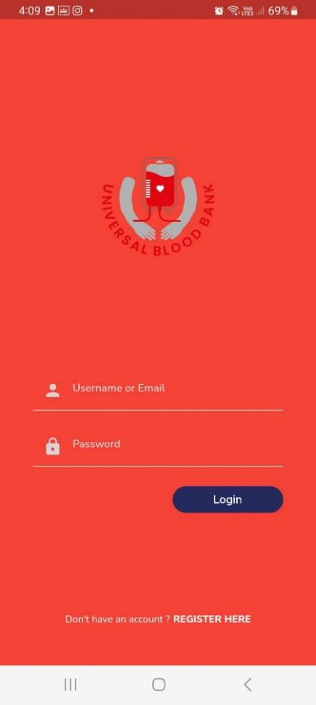

*Figure 1.* Sample Screen of System Page

Figure 1 shows the login page for a blood bank application it allows users to securely access their accounts by entering a username/email and password. It includes features like "Forgot Password" and "Sign Up" links. The server verifies the credentials, creating a session or token for successful logins, while providing error messages for failed attempts. Security measures include rate limiting, captchas, and optional two-factor authentication. Upon logging in, users access personalized features based on their role (donor, staff, or administrator), and the system logs activities for security monitoring.

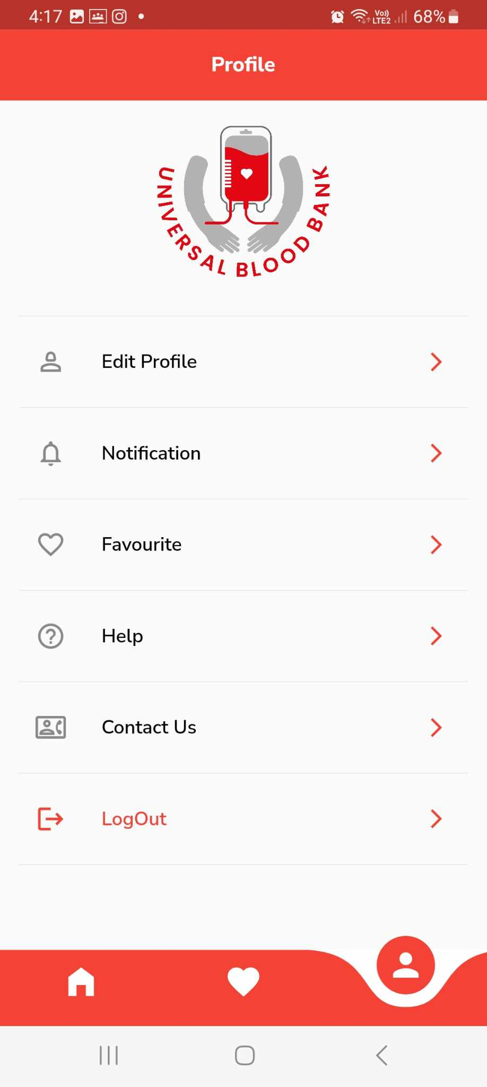

*Figure 2.* Sample Screen of System Page

Figure 2 shows blood bank dashboard page this is a user-friendly interface that displays real-time information about blood inventory, donor activities, and blood requests. It features an overview of current stock levels for each blood type, alerts for low stock and expiring units, recent donor activities, and upcoming donation events. The dashboard also tracks pending and fulfilled blood requests, shows results from quality control tests, and provides analytics through visual charts and reports. The dashboard is built using web technologies and a secure backend, ensuring efficient and safe management of blood bank operations.

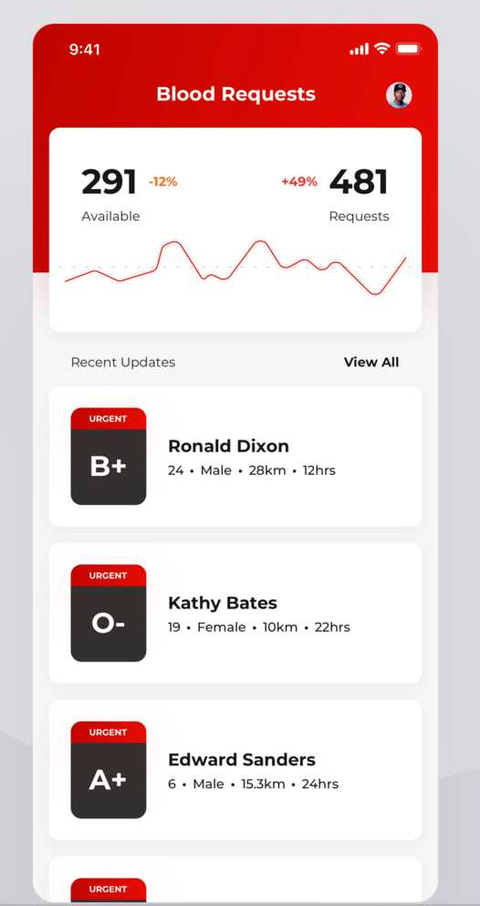

*Figure 3.* Sample Screen of System Page

Figure 3 shows the blood bank blood stock application helps manage and track blood inventory efficiently. It includes features for registering donors, scheduling donations, and recording blood collection and testing details. The application monitors blood stock levels, alerts staff about low stock or expiring units, and processes blood requests from hospitals. It generates reports on inventory, donation trends, and blood usage, aiding in resource planning. Built with secure web technologies, it ensures smooth and safe blood bank operations.

**DEFINITION OF TERMS**

For clarity of presentation, the following terms are defined as used in the study.

# Operational Terms

**Blood Management System:** A system designed to automate processes related to blood donation, inventory management, donor engagement, and monitoring of blood banks within the Red Cross organization.

**Donor Finder:** A feature within the system that helps identify and engage blood donors by tracking their donation history and providing recognition for their contributions.

**Blood Donation Programs**: Organized events held in various locations such as schools, malls, city halls, and companies to encourage voluntary blood donations.

**Blood Inventory Management:** The process of maintaining real-time records of available blood stock, updating inventory levels, and setting alerts for low stock levels.

**System Evaluation:** The assessment of the developed system based on criteria such as functionality, usability, efficiency, maintainability, and portability to ensure it meets the desired objectives.

# Technical Terms

**ISO 9126:** A standard used for evaluating software quality characteristics, including functionality, usability, efficiency, maintainability, and portability.

**Primary Data:** Information collected directly from surveys and interviews to determine system requirements and features needed for system development.

**Web-Based Environment:** An online platform that allows efficient management and retrieval of data, providing access to blood stock inquiries and management features.

**PHP Programming Language:** A popular scripting language used for web development, often employed in creating dynamic web pages and web applications.

**MySQL:** A widely used open-source relational database management system (RDBMS) that stores and manages data for web-based applications.

**CHAPTER 3**

**METHODOLOGY**

In this chapter, the methodologies used throughout the study are described together with the diagram presentation. Here are the following sections that will be discussed in this chapter: Requirements Analysis, Requirement Documentation, Design of Software, System Product and/or Process, Development and Testing and Implementation Plan.

**REQUIREMENTS ANALYSIS**

The Red Cross Muntinlupa Chapter faces significant challenges in managing blood donations due to manual appointment scheduling and communication gaps between donors and recipients.

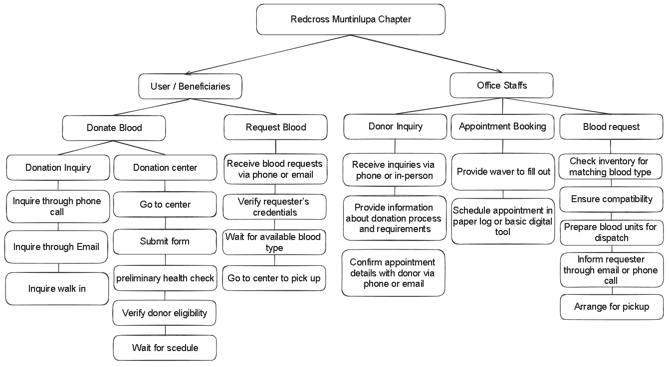

*Figure 4.* Functional Decomposition Diagram of Redcross Muntinlupa Blood Request Existing Process and Communication Between Donors and Recipients

The Red Cross Muntinlupa Center's appointment and blood request processes are inefficient and prone to errors due to their reliance on phone calls, in-person visits, and record-keeping. Donors contact the center to schedule appointments, and staff check available slots and record information, leading to delays and higher no-show rates due to the lack of automated reminders. Similarly, recipients request blood by phone or in-person, with staff verifying inventory and coordinating pickups or deliveries. If the required blood type is unavailable, recipients are placed on a waiting list, and staff reach out to potential donors. This outdated communication method causes delays and hinders quick donor mobilization. An automated system is needed to enhance efficiency, reduce errors, and improve donor and recipient engagement.

**REQUIREMENTDOCUMENTATION**

The Functional Decomposition Diagram (FDD) for the proposed system at the Red Cross Muntinlupa Center outlines key functions to streamline and improve blood donation management. The system includes automated appointment scheduling through a user-friendly mobile app, efficient blood collection procedures with integrated health screenings, and real-time blood inventory management. Enhanced communication features ensure timely notifications and coordination between donors and recipients. This technology-driven approach aims to increase efficiency, reduce errors, and improve the overall blood donation experience.

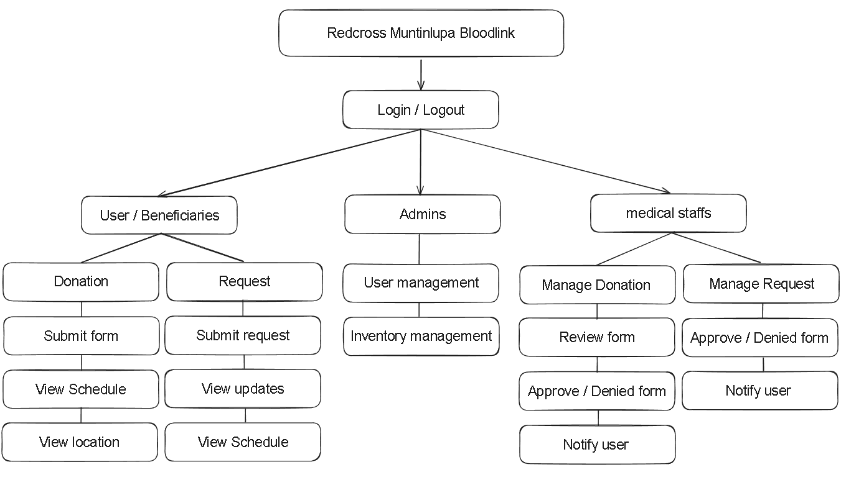

*Figure 5.* Functional Decomposition Diagram of the Proposed System

Figure 5 illustrates the Redcross Muntinlupa Bloodlink system’s architecture, mapping out the essential functions for various user roles such as ‘User/Beneficiaries,’ ‘Admins,’ and ‘Medical Staffs.’ It details the system’s access points through ‘Login/Logout,’ delineates the donation and request procedures for users, outlines administrative control over user management and inventory, and describes the medical staff’s responsibilities in approving forms and facilitating communication. This hierarchical diagram accentuates the system’s structured operational workflow and the specific duties assigned to each user group.

**System Architecture**

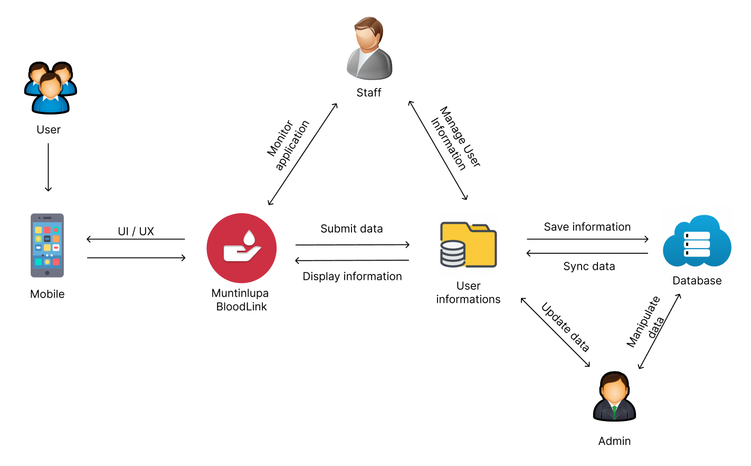

*Figure 6.* System Architecture of the proposed Application

figure 6 illustrates the comprehensive system architecture of the proposed application, designed to facilitate seamless interaction between users, staff, and system administrators. The architecture is depicted as a flowchart, emphasizing the integral components and their inter connectivity.

**User Interface (UI)/User Experience (UX)** component is represented, indicating the point of contact for users through mobile devices. This interface is directly linked to the Muntinlupa BloodLink module, which serves as the core platform for users to submit and retrieve information.

**Staff** module is shown to have bidirectional communication with both the data submission and information display functions, signifying their role in managing and overseeing these processes.

**Admin** , which maintains oversight over user information and system operations. It is connected to a Database, which is responsible for the storage, synchronization, and updating of user profiles and system data.

**Save Information**, **Sync Data**, and **Update User Profile** , showcasing the dynamic capabilities of the system to manage and process data efficiently.

**DESIGN OF SOFTWARE, SYSTEMS, PRODUCT AND/OR PROCESS**

On the basis of foregoing concepts, theories and findings of related literature, Studies and insights taken from them a concept model was develop as shown below. It shows in the input the requirements used in the application by the developers such as knowledge algorithm, software requirements and the hardware requirements and the user will used it also includes the methodology and the researcher.

|  |  |  |  |  |  |  |  |  |
| --- | --- | --- | --- | --- | --- | --- | --- | --- |
| |  | | --- | | **Knowledge Requirements**  - Database Management  - Mobile Development  - Backend Devepment and APIs  - Software tools  - Frontend Development and frameworks  - Mobile App Development platform | | **Software Requirements**  - Visual Studio  - Git/Github  - JavaScript  - Node.js  - Expo Go  - MySql  - Nativewind  - ChatGPT | | **Hardware Requirements**  - Computer  - Internet Connection  - Mobile Devices | |  |   **INPUT** | **PROCESS**   |  | | --- | | **RAD Methodology**  - Requirements Analysis and Planning  - Software Architecture and Design  - System Construction  - Cutover | | **OUTPUT**   |  | | --- | | **Blood Link: A Mobile-Based Hybrid Blood Bank For Red Cross Muntinlupa Chapter** | |
| |  | | --- | | **Evaluation**  (ISO/IEC 2501:2011) | | | | | |

*Figure 7.* Conceptual Model of the Study

The model outlines a study’s workflow, starting with INPUT requirements such as knowledge and software tools, moving through a PROCESS guided by RAD methodology, and culminating in an OUTPUT that includes a mobile-based blood bank application and its evaluation.

**DEVELOPMENT AND TESTING**

**Project Development**

The researchers use the Rapid Application Development (RAD) model is based on prototyping and iterative development with no specific planning involved. The process of writing the software itself involves the planning required for developing the product. Rapid Application development focuses on gathering customer requirements through workshop or focus groups, early testing of prototypes by the customer using interactive concepts reuse of existing prototypes(components) continuous integration and rapid delivery.

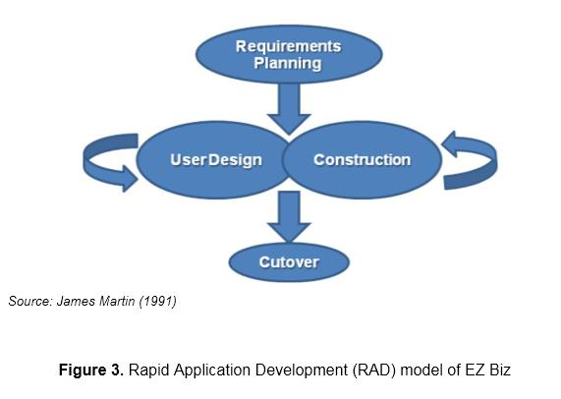

*Figure 8*.Rapid Application Development (RAD) Methodology

Figure 8 shows a process model that accelerates software development by iterating through four phases: defining project goals in Requirements Planning, refining system design with user feedback in User Design, rapidly constructing a functional model during Construction, and transitioning the product to the users in Cutover. This methodology emphasizes user involvement and rapid prototyping.

**Phase 1: Requirements Planning**

The researcher first gathers data and plans to develop the system using React Native for the application’s development. In any case, probably in proposing a system the developers should have talked about the mechanics of the plans first before doing the system. The developers should know the problem of the users and even more in the selected beneficiary. The researchers identify that problem and plans its best solution. To develop the application, the researcher gathered/prepared all the requirements to start the application development.

**Phase 2: Design phase**

The design phase focuses on translating requirements into detailed design specifications. User interface designs, system architecture, and database schema are established during this phase, ensuring a clear roadmap for implementation.

React Native is chosen as the development framework for the mobile application interface due to its ability to provide cross-platform capabilities. This allows the team to develop a single codebase that can run on both iOS and Android devices, streamlining development efforts and reducing time-to-market. React Native's component-based architecture facilitates the creation of reusable UI elements, ensuring consistency across different screens and functionalities within the blood bank application.

**Phase 3: Construction**

During the construction phase, the actual development of the mobile-based hybrid blood bank system takes place. Using the React Native framework, the researchers implement features such as donor registration, appointment scheduling, real-time inventory updates, and communication tools. Continuous integration allows for rapid prototyping and iterative development.

**Phase 4: Cutover Phase**

The cutover phase involves transitioning from the existing blood bank system to the new mobile-based hybrid system. Data migration, user training, and system testing are conducted to ensure a smooth transition. Stakeholder engagement and feedback play a crucial role in validating system functionality and usability.

**Testing Procedure**

When testing the application to find out where the system fault occurs, a testing technique is required. Even while it cannot ensure that all flaws in a program will be eliminated, if the software is tested effectively and precisely, it can minimize the amount of defects to the absolute minimum. To ensure that a program and the system it controls can operate as intended, program tests were carried out in a predetermined order.

**Table 1**

*Alpha Testing*

|  |  |
| --- | --- |
| **Aspect** | **Alpha Testing** |
| Purpose | Identify and fix bugs, enhance features, and ensure the system meets requirements |
| Participants | Developers, testers, and selected internal users |
| Scope | All major features including Database Connection |
| Focus Areas | Functionality, usability, performance, and security |
| Duration | Typically shorter, lasting a few weeks |
| Feedback | Collected from development team |
| Issue Resolution | Immediate and iterative, as issues are reported and fixed quickly |
| Output | Improved and more stable version of the system |

Alpha testing phase in software development, highlighting its purpose, participants, focus areas, scope, duration, issue resolution, and the expected output of an improved system.

**Table 2**

*Beta Testing*

|  |  |
| --- | --- |
| **Aspect** | **Alpha Testing** |
| Purpose | Validate the system's performance, usability, and reliability in real-world scenarios |
| Participants | A broader group of actual end-users |
| Scope | Real-world usage of the system by actual users |
| Focus Areas | User experience, system performance, and overall reliability |
| Duration | Typically longer, lasting several weeks to months |
| Feedback | Collected from actual end-users |
| Issue Resolution | Issues are documented for post-beta fixes and improvements |
| Output | Final adjustments and fixes leading to the official release |

Beta testing phase in software development, which includes validating system performance, usability, and reliability with a broader group of end-users, focusing on user experience and system reliability over several weeks to months, leading to the final product release.

**Project Evaluation**

The evaluation instrument was based on the characteristics and sub-characteristics provided by ISO/IEC 25010:2011. Respondents of the study were the individual users of the system such as the 10 Information Technology (I.T.) experts and 20 actual users. Purposive sampling was used to select the number of respondents. Purposive sampling is a non-probability sampling technique; it is a form of sampling in which the selection of the sample is based on the judgment of the researchers as to which subjects.

**Table 3**

*System Evaluation Characteristics ISO/IEC 25010:2011 Software Evaluation*

*for both Users and IT Experts*

|  |  |
| --- | --- |
| **Software Characteristics** | **Description** |
| Functionality Suitability | Degree to which a product or system provides functions that meet stated and implied needs when used under specified conditions. |
| Performance Efficiency | Performance relative to the amount of resources used under stated conditions |
| Compatibility | Degree to which a product, system or component can exchange information with other products, systems or components and/or perform its required functions, while sharing the same hardware or software environment |
| Usability | Degree to which a product or system can be used by specified users to achieve specified goals with effectiveness, efficiency and satisfaction in a specified context of use |
| Reliability | Degree to which a system, product or component performs specified functions under specified conditions for a specified period of time |
| Security | Degree to which a product or system protects information and data so that persons or other products or systems have the degree of data access appropriate to their types and levels of authorization |
| Maintainability | Degree of effectiveness and efficiency with which a product or system can be modified by the intended maintainers |
| Portability | Degree of effectiveness and efficiency with which a system, product or component can be transferred from one hardware, software or other operational or usage environment to another |

The statistical tool were used in the interpretation of data is weighted arithmetic mean as shown at table 3. Arithmetic mean is used to determine the average responses of the five option in each item, namely, 5(excellent), 4(very good), 3(good), 2(fair) and 1(poor). The arithmetic means for each software characteristics were computed. These were used to derive the overall evaluation mean.

## Table 4

*Likert Scale*

|  |  |  |
| --- | --- | --- |
| **Scale** | **Range of Mean Value** | **Interpretation** |
| 5 | 4.51 – 5.00 | Excellent |
| 4 | 3.51 – 4.50 | Very Good |
| 3 | 2.51 – 3.50 | Good |
| 2 | 1.51 – 2.50 | Fair |
| 1 | 1.00 – 1.51 | Poor |

**IMPLEMENTATION PLAN**

After finalizing the Blood Link system, it will be presented to the Red Cross Muntinlupa Chapter for evaluation. If approved for implementation, the complete system and its documentation will be submitted to the Red Cross Muntinlupa Center for deployment.

**Table 5**

*Implementation Table*

|  |  |  |  |
| --- | --- | --- | --- |
| **Strategy** | **Activities** | **Persons Involved** | **Duration** |
| Approval from the company | Send letters for the approval of Administrators | Researchers, Administrator | 1 – 2 Days |
| System  Installation | Installation of the system and checking of the facility that needs an upgrade (software and hardware). | Researchers, Administrator | 2 - 3 Days |
| Information Distribution | Send Flyers, Brochures,  Posters, and User Manual | Researchers, Administrator | 1 Day |
| 3- Day  Training | Hands-on Training and System Demo/ Lectures | Researchers, Adviser,  Officer and  Administrator | 3 Days |

**REFERENCES**

[1] Li L, Valero M, Keyser R, Ukuku AM, Zheng D. Mobile applications for encouraging blood donation: A systematic review and case study. Digit Health. 2023 Oct 8;9:20552076231203603. doi: 10.1177/20552076231203603. PMID: 37822963; PMCID: PMC10563464.

[2] O. Iparraguirre-Villanueva, F. Sierra-Liñan, M. Cabanillas-Carbonell, “ 2022 Location-based Mobile Application for Blood Donor Search”. https://repositorio.uwiener.edu.pe/handle/20.500.13053/6889

[3] Gupta, S. Singh, P. Kumar, “ 2019 Blood Bank Android Application Collection Centre,” http://www.ir.juit.ac.in:8080/jspui/handle/123456789/6750

[4] Moh. Nabil et al 2020 J. Phys.: Conf. Ser. 1447 012001,https://iopscience.iop.org/article/10.1088/1742-6596/1447/1/012001/meta

[5] Al-Sammarraie, et.al (2022) Mobile-base Registration System for Blood Donation (MBRS-BD). Asian Journal of Research in Computer Science, 14 (4). Pp. 36-45. ISSN 2581-8260 http://scholar.sdpublishers.info/id/eprint/22/

[6] Ocen, et.al 2022 http://196.43.171.194/handle/20.500.12283/2467

[7] Lawas, K. , Glorioso, J. & Capuno, J. (2023). Sagot Ko Dugo Mo: A Blood Management System with Donor Finder for Red Cross Laguna Chapter. Ani: Letran Calamba Research Report, 19(1), 54-55.https://www.ejournals.ph/article.php?id=1965820

[8]. M. M. Hummady, "Design Mobile Application for Blood Donation System,"2022 International Conference on Computer and Applications (ICCA), Cairo, Egypt, 2022, pp. 1-5,doi: 10.1109/ICCA56443.2022.10039544

[9] A Research Paper on “ Blood Donation Management System" by A. Clemen Teena, K. Sankar (2021)

[10] Brasil Pan-Americana da Saúde (OPAS). Dia Mundial do Doador de Sangue 2019 Sangue seguro para todos (2019)

[11] G. Maji, N. C. Debnath and S. Sen, "Data Warehouse Based Analysis with Integrated Blood Donation Management System," 2018 IEEE 16th International Conference on Industrial Informatics (INDIN), Porto, Portugal, 2018, pp. 855-860, doi: 10.1109/INDIN.2018.8471988.

[12] A. Casabuena et al., "BloodBank PH: A Framework for an Android-based Application for the Facilitation of Blood Services in the Philippines," TENCON 2018 - 2018 IEEE Region 10 Conference, Jeju, Korea (South), 2018, pp. 1637-1641, doi: 10.1109/TENCON.2018.8650395

[13] Tatikonda VK, El-Ocla H. BLOODR: blood donor and requester mobile application. Mhealth. 2017 Sep 18;3:40. doi: 10.21037/mhealth.2017.08.08. PMID: 29184892; PMCID: PMC5682362.

[14] Kulkarni, S. S., & Kulkarni, S. S. (2016). Mobile Blood Donation System for Blood Banks. International Journal of Computer Applications, 134. https://doi.org/10.5120/ijca2016909732

[15] M. R. A. Brislin, J. A. Mayan, R. A. Canessane and M. R. A. Hamlin, "Blood donation and life saver app," 2017 2nd International Conference on Communication and Electronics Systems (ICCES), Coimbatore, India, 2017, pp. 446-451, doi: 10.1109/CESYS.2017.8321318.

[16] M. Fahim, H. I. Cebe, J. Rasheed and F. Kiani, "mHealth: Blood donation application using android smartphone," 2016 Sixth International Conference on Digital Information and Communication Technology and its Applications (DICTAP), Konya, Turkey, 2016, pp. 35-38, doi:10.1109/DICTAP.2016.7543997.